GRAMMAR
ACTIVE AND PASSIVE VOICE
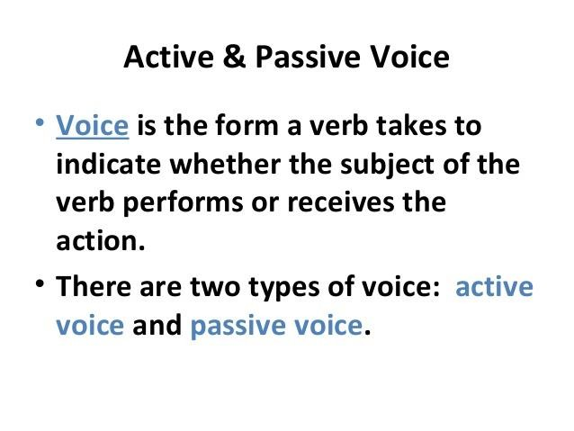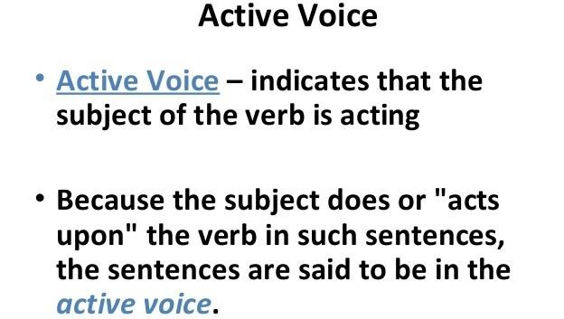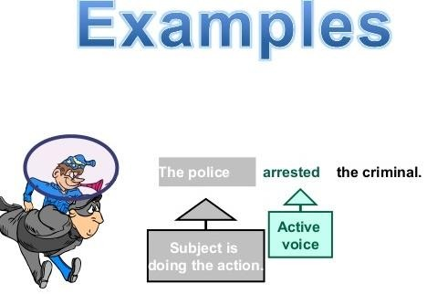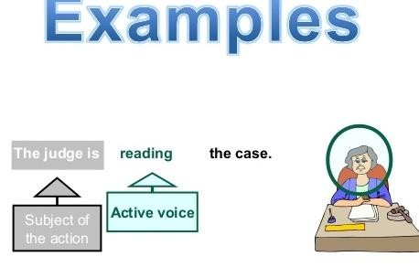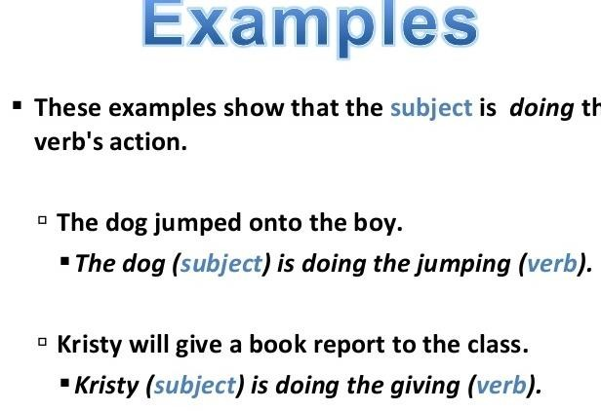

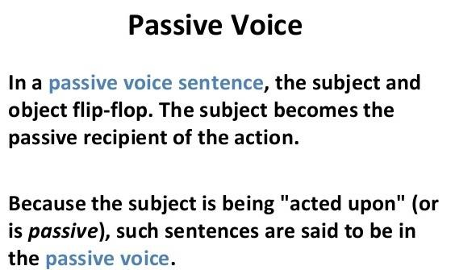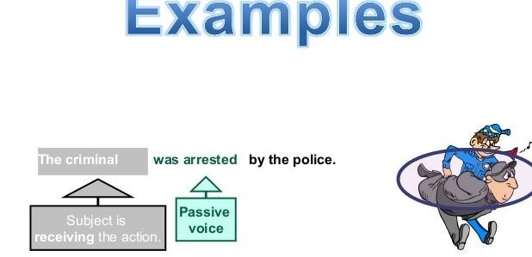

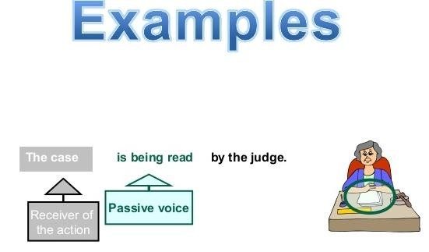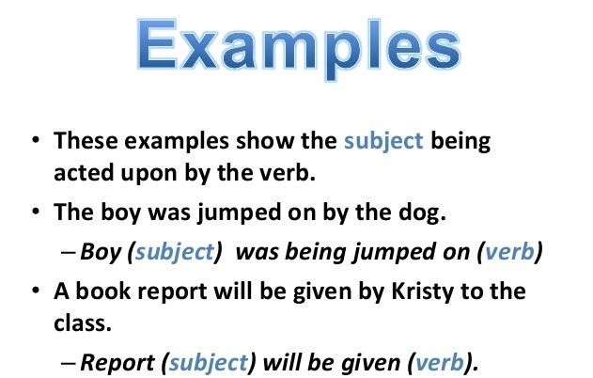

RULES OF ACTIVE AND PASSIVE VOICE
Rule 1 :
- Simple Present Tense
Active Sentences | Passive Sentences
He writes an essay | An essay is written by him
Sheena does the housework | The housework is done by Sheena
She cares for the rabbit | The rabbit is being cared for by her
Jacob always plays the guitar | The guitar is always played by Jacob

Rule 2 :
- Present Continuous Tense
Active Sentences | Passive Sentences
They are eating bananas | The bananas are being eaten by them
Bob is drawing a diagram | A diagram is being drawn by Bob
Samta is playing the piano | A piano is being played by Samta
She is waiting for Reema | Reema is being waited for by her
Rule 3:
- Simple Past Tense
Active Voice | Passive Voice
Ria paid the bills | The bills were paid by Ria
The teacher called the student | The student was called by the teacher
She did not buy the fruits | The fruits were not bought by her
Rule 4:
- Past Progressive/Continuous Tense
Active Voice | Passive Voice
They were waiting for him | He was being waited for by them
Astha was learning French | French was being learnt by Astha
She was playing kabaddi | Kabaddi was being played by her
Rule 5:
- Past Perfect Tense
Active Voice | Passive Voice
She won the match | The match had been won by her
I had finished her work | Her work had been finished by me
He had missed the last metro | The last metro had been missed by
Rule 6:
- Simple Future Tense
Active Voice | Passive Voice
He will write a letter | A letter will be written by him
He will repair her cycle | Her cycle will be repaired by him
He shall start the meeting | The meeting will be started by him

Rule 7:
- Future Perfect Tense
Active Voice | Passive Voice
Meena will not have changed the bedsheet | The bed sheet will not have been changed by  Meena
They will have won the match | The match will have been won by them
Reena will have washed the skirt | The skirt will have been washed by Reena

ACTIVE AND PASSIVE VOICE

CHANGE THE FOLLOWING SENTENCES INTO PASSIVE VOICE:
- He teaches English.
ANS: - English is taught by him.
- The child is eating bananas.
ANS: - Bananas are being eaten by the child.
- She is writing a letter.
ANS: - A letter is being written by her.

- The master punished the servant.
ANS: - The servant was punished by the master.
- He was writing a book.
ANS: - A book was being written by him.
- Who wrote this letter?
ANS: - By whom was this letter written?
- Somebody cooks meal every day.
ANS: - Meal is cooked every day (by somebody).
- He wore a blue shirt.
ANS: - A blue shirt was worn by him.
- May God bless you with happiness!
ANS: - May you be blessed with happiness (by God)!
- They are building a house.
ANS: A house is being built by them.
- I have finished the job.
ANS: The job has been finished by me.
- I sent the report yesterday.
ANS: - The report was sent by me yesterday.
- She bought a diamond necklace.
ANS: - A diamond necklace was bought by her.
- Somebody had stolen my purse.
ANS: - My purse had been stolen (by somebody).

- The librarian arranged the books in the shelf.
ANS: - The books were arranged in the shelf by the librarian.
- John collects money.
ANS: - Money is collected by John.
- Anna opened the window
ANS: - The window was opened by Anna.
- We have done our homework.
ANS: - Our homework has been done by us.
19.The Government is planning a new road near my house
ANS: - A new road is being planned near my house by the Government.
- My grandfather built this house in 1943.
ANS: - This house was built by my grandfather in 1943.
- Picasso was painting Guernica at that time.
ANS: - Guernica was being painted by Picasso at that time.
- The cleaner has cleaned the office.
ANS: - The office has been cleaned by the cleaner.
- He had written three books before 1867.
ANS: - Three books had been written by him before 1867.
- By this time tomorrow we will have signed the deal.
ANS: - The deal will have been signed by this time tomorrow.
- People speak Portuguese in Brazil.
ANS: - Portuguese is spoken in Brazil (by people).
- Everybody loves Mr. Brown.
ANS: - Mr. Brown is loved by everybody.
- The wolf ate the princess in the story.
ANS: - The princess was eaten by the wolf in the story.
- Somebody has drunk all the milk!
ANS: - All the milk has been drunk (by somebody).
- A workman will repair the computer tomorrow.
ANS: - The computer will be repaired tomorrow by a workman.
- Somebody must have taken my wallet.
ANS: - My wallet must have been taken (by somebody).
- Mother made a cake yesterday.
ANS: - A cake was made by mother yesterday.
- I will never forget this experience.
ANS: - This experience will never be forgotten by me
- Did she do her duty?
ANS: - Was her duty done by her?
- Have you finished the report?
ANS: - Has the report been finished by you?

CHANGE INTO ACTIVE VOICE:
  - The jar is filled with sand.
ANS: - Sand fills the jar.
  - The thief is being interrogated by the police.
ANS: - The police are interrogating the thief.
  - Reading is enjoyed by Mary.
ANS: - Mary enjoys reading.
  - The house has been decorated by my mother.
ANS: - My mother has decorated the house.
  - The town was destroyed by fire.
ANS: - Fire destroyed the town.
  - The matches have been cancelled by the board.
ANS: - The board has cancelled the matches.
  - The airplane was flown to Bermuda by the pilot
ANS: - The pilot flew the airplane to Bermuda.
  - You are requested to be quiet.
ANS: - Please be quiet.
9. Crackers were eaten by the puppy.
ANS: - The puppy ate the crackers.
10. The clothes are designed by the famous designer.
ANS: - The famous designer designs the clothes.
11. The thief had been caught by the police.
ANS: - The police had caught the thief.

12. The cheese was eaten by Sara.
ANS: - Sara ate the cheese.
13. I have been invited to their party.
ANS: - They have invited me to their party.
14. The dog was beaten by its master.
ANS: - Its master beat the dog
15. The flowers have been plucked by the children.
ANS: - The children have plucked the flowers.
16. Short stories are written by her.
ANS: - She writes short stories.

SOME ADDITIONAL SENTENCES:
  - Active: Carry it home. 4. Active: Throw the ball. Passive: Let it be carried home Passive: Let the ball be thrown.
  - Active: Do it at once. 5. Active: Help me. Passive: Let it be done at once. Passive: You are requested to help me.
  - Active: Open the door. 6. Active voice: Who wrote this book?
Passive: Let the door be opened. Passive voice: By whom was this book written?

